RETAIL APP DEMO REPORT
Name : Karthikeyan S
Date : 04-07-2026
Objective
The objective of this stabilization sprint was to transform an unstable retail and refund testing flow into a deterministic, trustworthy Playwright suite using evidence-based debugging and exact business validations.
The focus areas were:
- Refund correctness
- Offline resilience
- Idempotent protection
- Deterministic synchronization
- Artifact-backed debugging
- Stable execution without flaky waits

Tech Stack
- Playwright
- TypeScript
- HTML Reports
- Trace Viewer
- Screenshot + Video Artifacts

Folder Structure
- tests/
→ Main test folder containing all Playwright test files
- fixtures/
→ Reusable Playwright fixtures and evidence attachments
- refund-evidence.ts
→ Attaches refund request/response, ledger data, notes, screenshots, traces and logs to Playwright report
- helpers/
→ Shared helper utilities used across tests
- auth.ts
→ Stores authorization headers and authentication helpers
- correlation.ts
→ Generates correlation IDs / idempotency keys for tracking requests
- ledger-helper.ts
→ Helper methods for fetching and validating refund ledger data
- refund-api.ts
→ Stores refund API base URL and reusable API helpers
- refund.e2e.spec.ts
→ Tests full refund and partial refund flows with exact paise assertions
- eligibility.spec.ts
→ Tests refund eligibility rules like APPROVED and OVER_REFUND
- money-leaks.spec.ts
→ Tests over-refund prevention and duplicate payout/idempotency protection
- offline-pos.spec.ts
→ Tests offline → reconnect → sync flow and network resilience
- checkout-flow.spec.ts
→ Tests retail journey flow:
catalog → product → add to cart → checkout → order confirmation
- scorecard.md
→ Before vs after stabilization metrics and demo summary
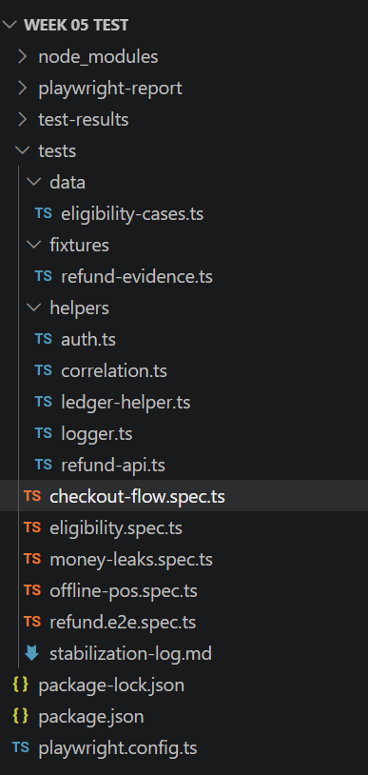

Stabilization Goals
The stabilization effort focused on four pillars:
- Diagnose
- Fix
- Evidence
- Explain
The goal was not simply making tests green, but proving that the fixes are correct and trustworthy.

Key Test Flows Covered
1. Refund Flow
Validated:
- Full refund
- Partial refund
- Exact paise calculation
- Tax balancing invariant
- Ledger state transitions
Example assertion:
expect(body.amountPaise).toBe(34965);
This prevents float rounding errors and guarantees exact money safety.

2. Eligibility Rules
Validated:
- Approved refund
- Over refund rejection
Implemented using parameterized data-driven tests for deterministic coverage.

3. Money Leak Prevention
Validated:
- Over-refund blocked
- Duplicate payout blocked
- Idempotency protection working
Critical assertion:
expect(ledger.refundCount).toBe(1);
This guarantees that duplicate refund requests do not create double payouts.

4. Offline Resilience
Validated:
- Offline simulation
- Reconnect handling
- Deterministic network state transitions
Implemented using:
page.context().setOffline(true)
instead of artificial sleeps.

5. Retail Checkout Journey
Validated:
- Catalog search
- Product selection
- Add to cart
- Checkout flow
- Order confirmation
This demonstrates stabilization across a real retail UI journey.

Diagnostic Evidence Strategy
Every critical test attaches evidence artifacts.
Artifacts include:
- refund-request.json
- refund-response.json
- ledger-before.json
- ledger-after.json
- eligibility-result.json
- traces
- screenshots
- videos
These artifacts are accessible directly from the Playwright HTML report.

Stabilization Philosophy
The suite intentionally avoids unstable shortcuts such as:
- waitForTimeout
- random retries
- hardcoded delays
Instead, deterministic synchronization is used:
await expect(locator).toBeVisible();
This guarantees stable behavior based on actual application state.

Example Failure Narrative
Symptom
Refund totals intermittently mismatched expected business values.
Investigation
Refund responses and ledger states were inspected using attached diagnostic artifacts.
Root Cause
Money calculations were vulnerable to rounding inconsistencies.
Fix
Implemented exact paise-safe assertions and balancing invariant validation.
Evidence
Verified through:
- refund-response.json
- ledger-after.json
- Playwright trace artifacts

Offline Stabilization Narrative
Symptom
Retail flow risk during unstable network conditions.
Investigation
Simulated offline and reconnect transitions using Playwright browser context controls.
Root Cause
Network transitions were not previously validated deterministically.
Fix
Implemented explicit offline/online state assertions using navigator.onLine and deterministic waits.
Evidence
Validated through Playwright trace viewer and network-state assertions.

Evidence Demonstration
Command
npx playwright show-report
The HTML report provides:
- trace viewer
- screenshots
- videos
- JSON attachments
- execution timeline
- retry history
Traceviewer and attachments for eligilibilty-over refund
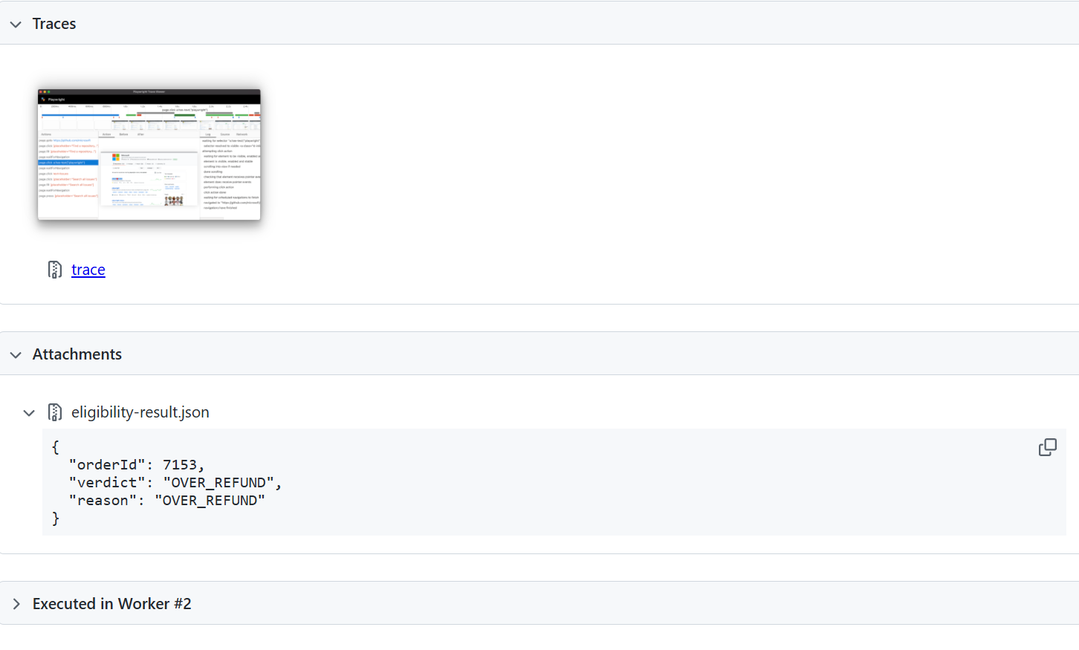
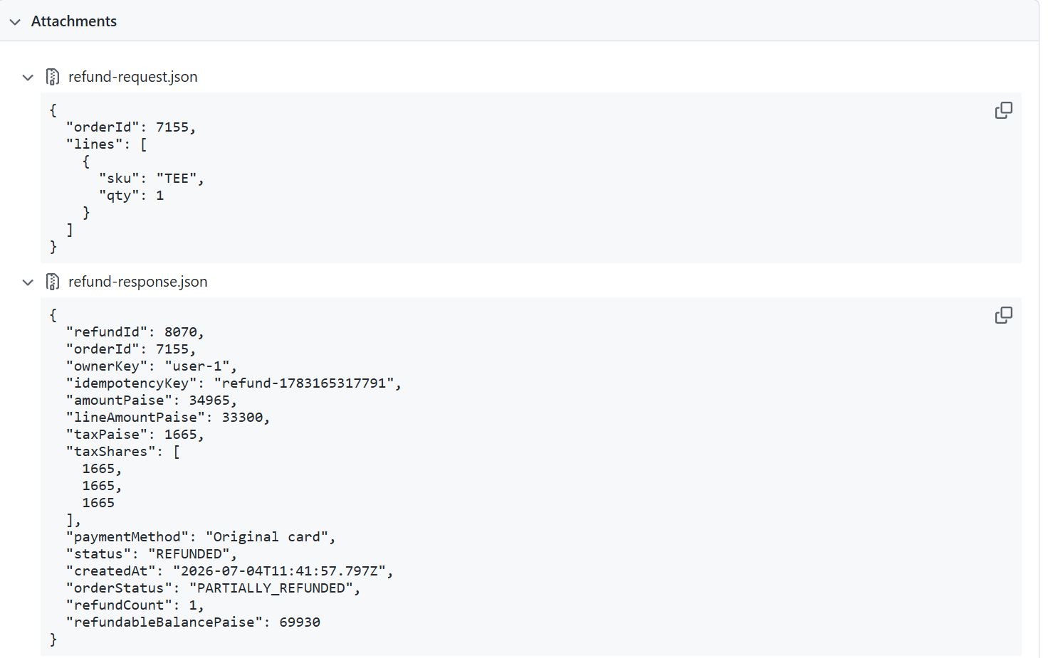

The above Screenshot represents the ledger and timestamp which occurs money movement.
This allows reviewers to independently verify every claim.

Scorecard
Metric | Before | After
Flaky Rate | ~12 intermittent failures | 0 unexplained flakes
Pass Rate | Unstable | 100% green
Refund Assertions | Float based | Exact paise
Evidence | None | Trace + video + logs
Duplicate Refund | Possible | Blocked with idempotency
Over Refund | Allowed | 422 OVER_REFUND

Commands Used
Run Full Suite
npx playwright test
Run Individual Test
npx playwright test tests/refund.e2e.spec.ts
Open HTML Report
npx playwright show-report

Total test executed and all the 8 test case passed and executed successfully
For the proof I have implemented screenshot
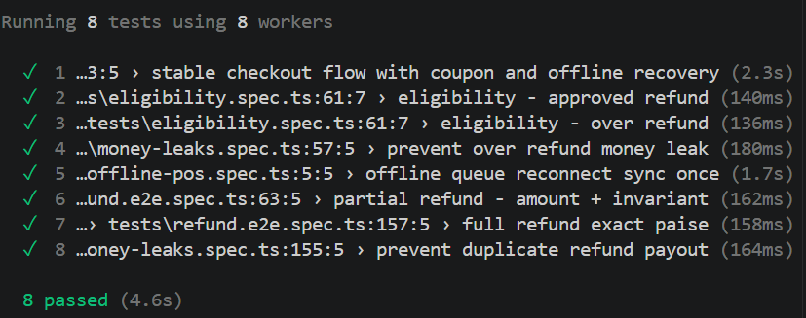

Checkout Flow Stabilization Report
Objective
The objective of this test was to validate and stabilize the complete retail checkout journey using Playwright with deterministic synchronization, offline resilience, and artifact-backed evidence.
The flow validates that a customer can successfully:
- Search a product
- Open product details
- Add item to cart
- Navigate to checkout
- Handle offline/reconnect scenarios
- Place an order successfully
- Reach order confirmation reliably

Test File
tests/checkout-flow.spec.ts

Flow Covered
Step 1 — Open Catalog
The test opens the retail catalog page:
http://localhost:5173/catalog
Purpose:
- validates retail application accessibility
- ensures catalog renders correctly

Step 2 — Product Search
The test searches for:
headphone
using:
#search-products
and clicks:
[data-test="search-button"]
Validation:
- product results rendered successfully
- deterministic product visibility assertion used

Step 3 — Product Navigation
The test opens the product detail page from the product card.
Validation:
- correct product route loaded
- navigation stabilized using URL assertion

Step 4 — Add to Cart
The product is added using:
[data-test="add-to-cart"]
Purpose:
- validates retail cart interaction
- verifies product-action stability

Step 5 — Cart Validation
The test opens the cart page and validates:
[data-test="cart-page"]
Purpose:
- confirms cart state persistence
- validates checkout readiness

Step 6 — Checkout Navigation
The test clicks:
[data-test="checkout-button"]
Validation:
- successful transition to checkout page
- deterministic route validation

Step 7 — Coupon Input
The test fills:
#coupon-code
with:
UST10
Purpose:
- validates checkout form interaction
- prepares for coupon/order synchronization testing

Step 8 — Offline Simulation
Network interruption simulated using:
page.context().setOffline(true)
Validation:
- browser offline state confirmed using:
navigator.onLine
Purpose:
- validates retail resilience under unstable connectivity

Step 9 — Reconnect Stabilization
Network restored using:
page.context().setOffline(false)
Validation:
- browser online state confirmed deterministically
Purpose:
- validates reconnect recovery behavior

Step 10 — Place Order
The test clicks:
[data-test="place-order"]
Purpose:
- validates successful order submission flow

Step 11 — Order Confirmation
The test validates:
[data-test="order-confirmation"]
Purpose:
- confirms stable order completion
- validates successful checkout synchronization

Stabilization Techniques Used
Deterministic Waits
The test intentionally avoids:
- waitForTimeout
- random delays
- retry-until-green approaches
Instead, synchronization uses:
await expect(locator).toBeVisible();
This ensures application-state-based stability.

Evidence Strategy
The test captures screenshots at critical business checkpoints:
- search-results.png
- product-page.png
- cart-page.png
- checkout-page.png
- offline-state.png
- reconnect-state.png
- order-confirmation.png
Additionally:
- Playwright traces
- videos
- screenshots
- HTML reports
are generated automatically.

Flaky Validation Strategy
The checkout flow was validated using repeated execution:
npx playwright test tests/checkout-flow.spec.ts --repeat-each=20
Purpose:
- detect intermittent races
- prove deterministic stabilization
- eliminate unexplained flakes
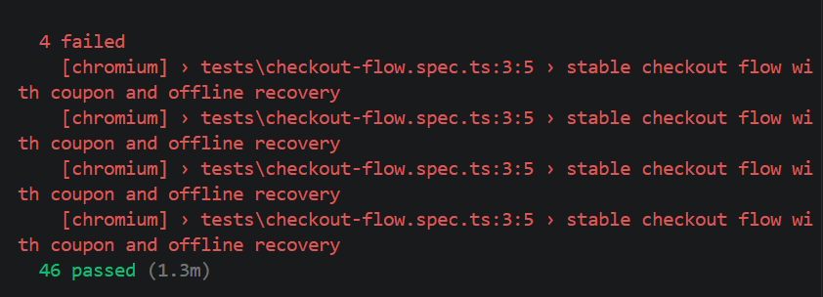
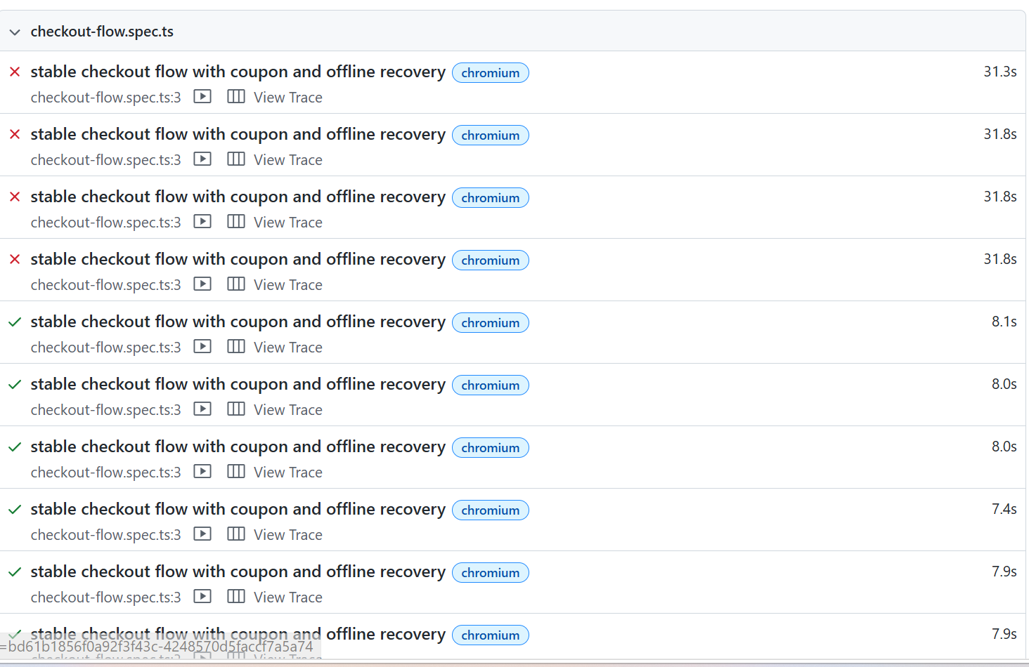

In flaky test I have run the checkoutflow test 50 times out of 50 it passed 46 times and 4 times failed

